Rwanda Children Education Foundation MicroCredit Global Grant

Since 2013 the Rwanda Children Education Foundation (RCEF), a Laconia, NH based 501C3 non-profit organization, had been providing school fees, scholastic materials, and supplemental food to poverty stricken children in Rwanda so that they could attend school. RCEF always had a plan to provide micro-loans to micro-business groups or families so that they may start local businesses to then be able to experience self-sufficiency and finance their children’s education on their own. But RCEF did not have the resources to start the micro-loan project. That is where the power of Rotary Global Grants came to make that plan come to reality.

In early 2019 seven New Hampshire Lakes Region Rotary clubs and Meredith Rotary’s Interact club donated $14,000 to the Rotary Foundation. Those donations were matched by District 7870’s District Designated Funds and The Rotary Foundation to create the $49,000 Rwanda Children Education Foundation MicroCredit Global Grant in April 2019.

Since last April, when the Global Grant got underway, there have been over 50 microcredit loans distributed and all have been on time in paying back their monthly loan payments, thus allowing more loans to be distributed again and again in the future.

Here is an example of how the Global Grant really making a difference in Rwanda…

============================================

Three ladies joined together six months ago to apply for a microcredit loan. Their plan involved grinding cassava roots along with other plant roots to make blended flour that is both a healthy and popular staple in Rwanda.

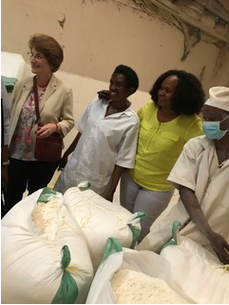
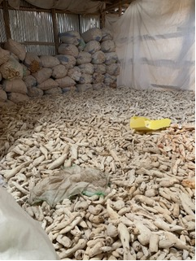
Cassava Roots Blended flour ready to be sent to stores

The business includes a place for materials storage and grinding, hired transportation, and two different retail outlets each staffed by one of the three partners.

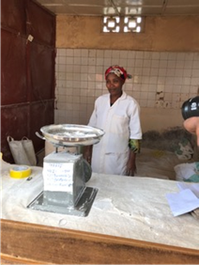
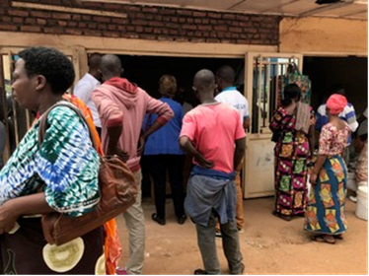
One of the stores selling the flour

The business has prospered and the ladies have been able to hire nearly a dozen helpers to assist them. All loan repayment dates have been met, in fact they are ahead of schedule! It is amazing to observe how creative and productive these ladies have been once given an opportunity.

The RCEF staff has told us that “Your contributions to the Rotary Global Grant Fund have made this possible.”

